**1.e)** Figure Q shows the overall Simulink model of the nonlinear system, and figures W-R show the Simulink models of the individual sub-systems.

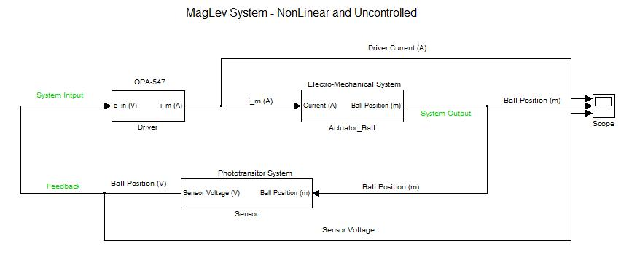

Figure Q. Nonlinear Simulink Model

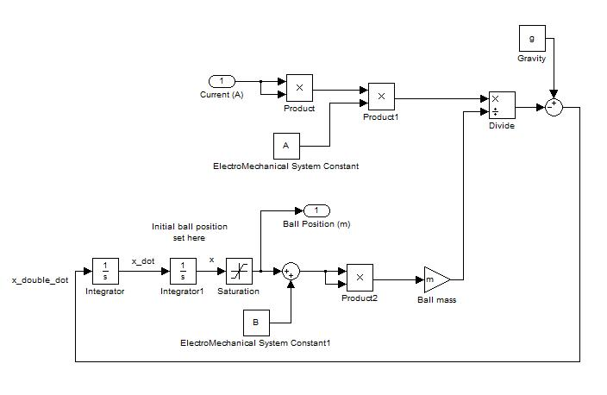

Figure W. Simulink Model of Actuator-Ball Sub-System

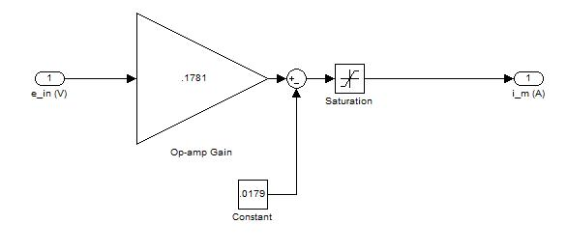

Figure E. Simulink Model of OPA-547 Op-Amp

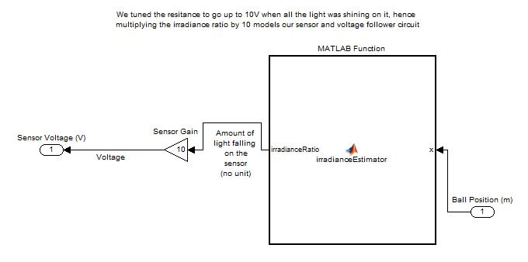

Figure R. Simulink Model of Phototransistor

Figure T shows the overall Simulink model of the linearized system, and figures Y-O show the Simulink models of the individual sub-systems.

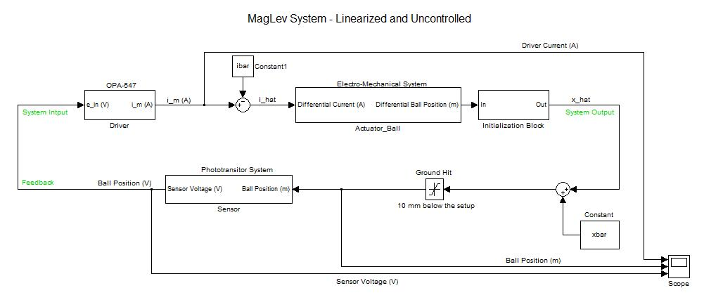

Figure T. Linearized Simulink Model

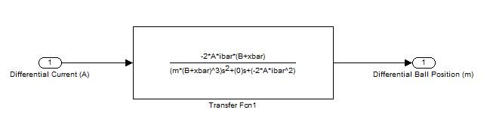

Figure Y. Simulink Model of Linearized Actuator-Ball Sub-System

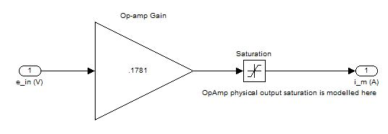

Figure U. Simulink Model of OPA-547 Op-Amp

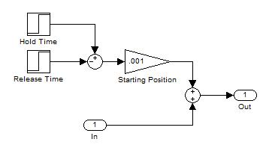

Figure I. Simulink Model of Initial Position Offset

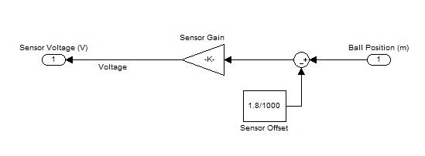

Figure O. Simulink Model of Phototransistor

**1.f)** Figure Z shows the time response of the nonlinear and linearized models when both are set to the nominal starting position ( $\overline{x}$ = 0.00323m). The time scale has been reduced to better show the behavior of both systems. In both cases the ball oscillates about a distance closer to the electromagnet than the starting point, with the ball in the nonlinear model ending up closer than the ball in the linearized model. In the case of the nonlinear model, the ball strikes the magnet before it begins oscillating, and the amplitude of its oscillations is less than the amplitude of the linearized model.



Figure Z. At Nominal Stating Height Both Systems Levitate, but Oscillate

In Figure X, the nonlinear and linearized models are both set to a position one mm above the nominal starting position. The time scale has been reduced to better show the behavior of both systems. The linearized model again oscillates about a distance closer to the electromagnet than the starting point, but with smaller amplitude than previously. In the case of the nonlinear model, the ball strikes the magnet, is released, is re-attracted to the magnet, and then falls away.



Figure X. When Starting One mm Closer to the Electromagnet, the Linearized Model Levitates and Oscillates, and the Nonlinear Model Falls

In Figure V, the nonlinear and linearized models are both set to a position one mm below the nominal starting position. The time scale has been reduced to better show the behavior of both systems. The behavior here is very similar to the previous case. The linearized model oscillates about a distance closer to the electromagnet than the starting point, but with greater amplitude than with the closer starting point. The ball in the nonlinear model again strikes the magnet, and is then released and falls away.



Figure V. When Starting One mm Further from the Electromagnet, the Linearized Model Levitates and Oscillates, and the Nonlinear Model Falls